**2023-1 Solid Mechanics Quiz #1**

(2023.04.11.)

『Please write all the answers on this test sheets. You can also use the back side for the answers.』

1. Two forces are applied to the construction bracket as shown. (a) Determine the angle which makes the resultant of the two forces vertical. (b) Determine the magnitude R of the resultant. [20 Points]

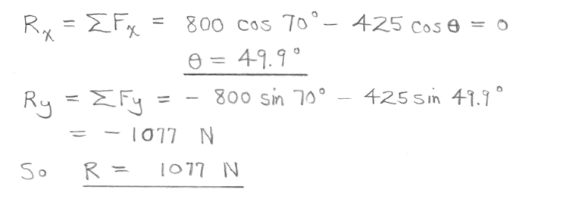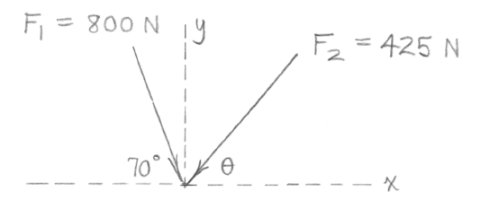

2. A force **F** of magnitude 60 N is applied to the gear. Determine the moment of **F** about point O. [10 Points]

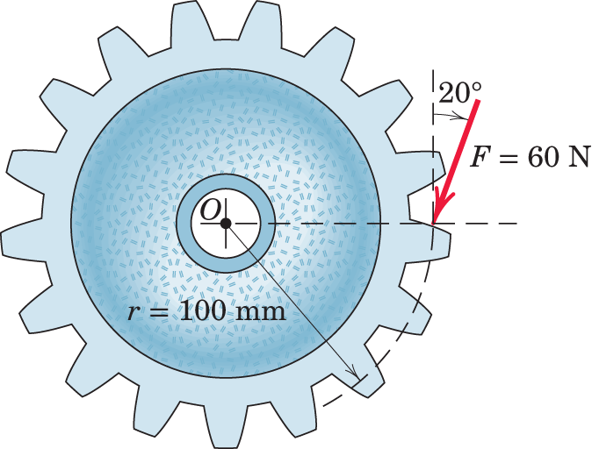

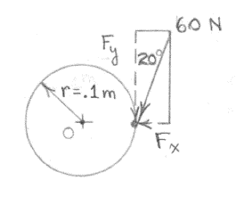

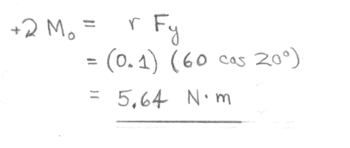

3. Calculate the magnitude of the moment about the base point O of the 600-N force in five different ways. [20 Points]

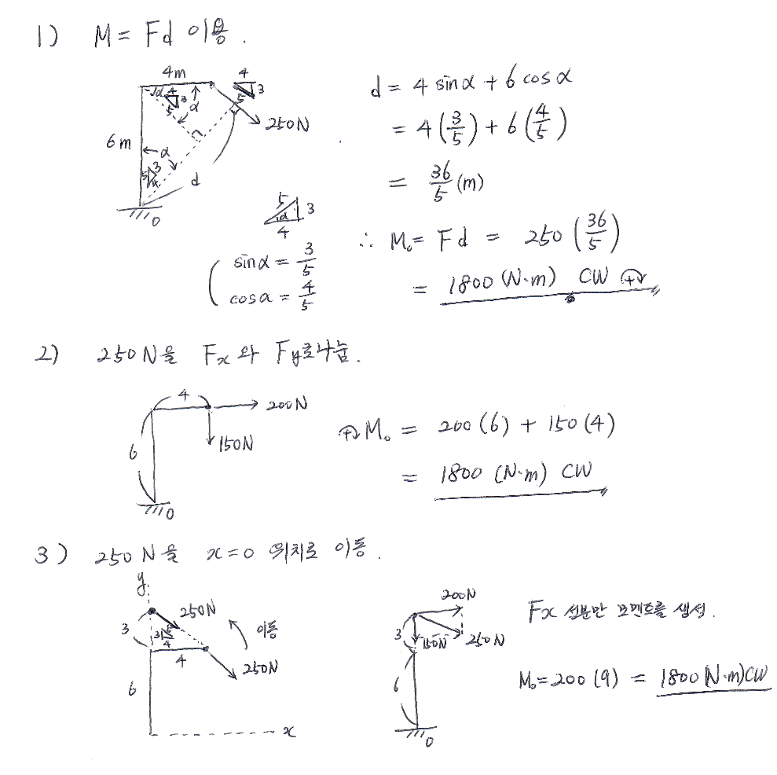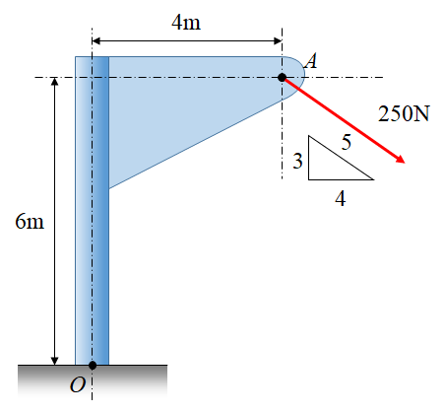

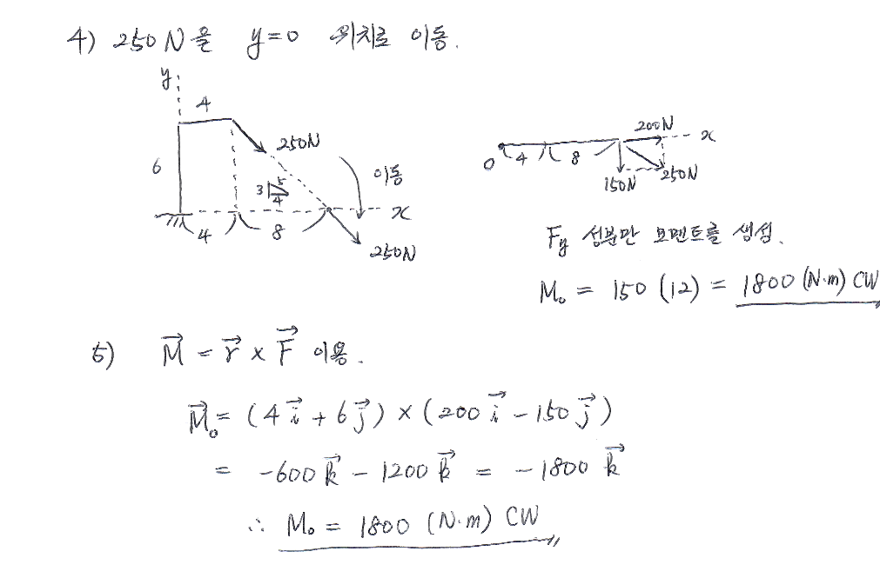

4. Calculate the reaction forces at point O. (Neglect the weight of the beam.) [30 Points]

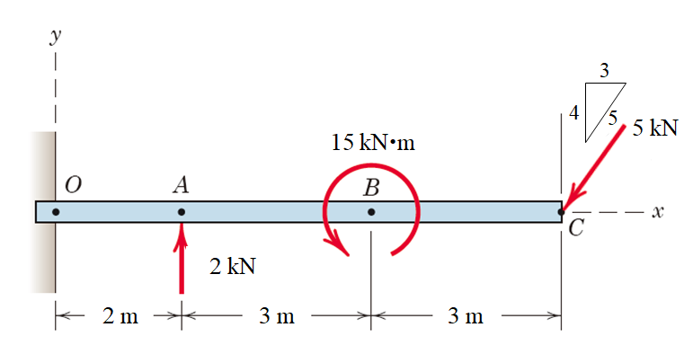

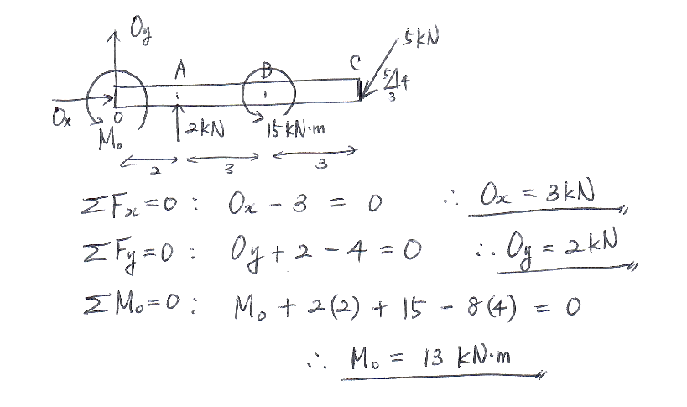

5. A simple asymmetric simple truss is loaded as shown. Determine the reactions at A and D. Neglect the weight of the structure compared with the applied loads. [20 Points]

